Cover Photo:
Maurice Gibb Memorial Park
Building Resilience, Community, and Connection in Miami Beach
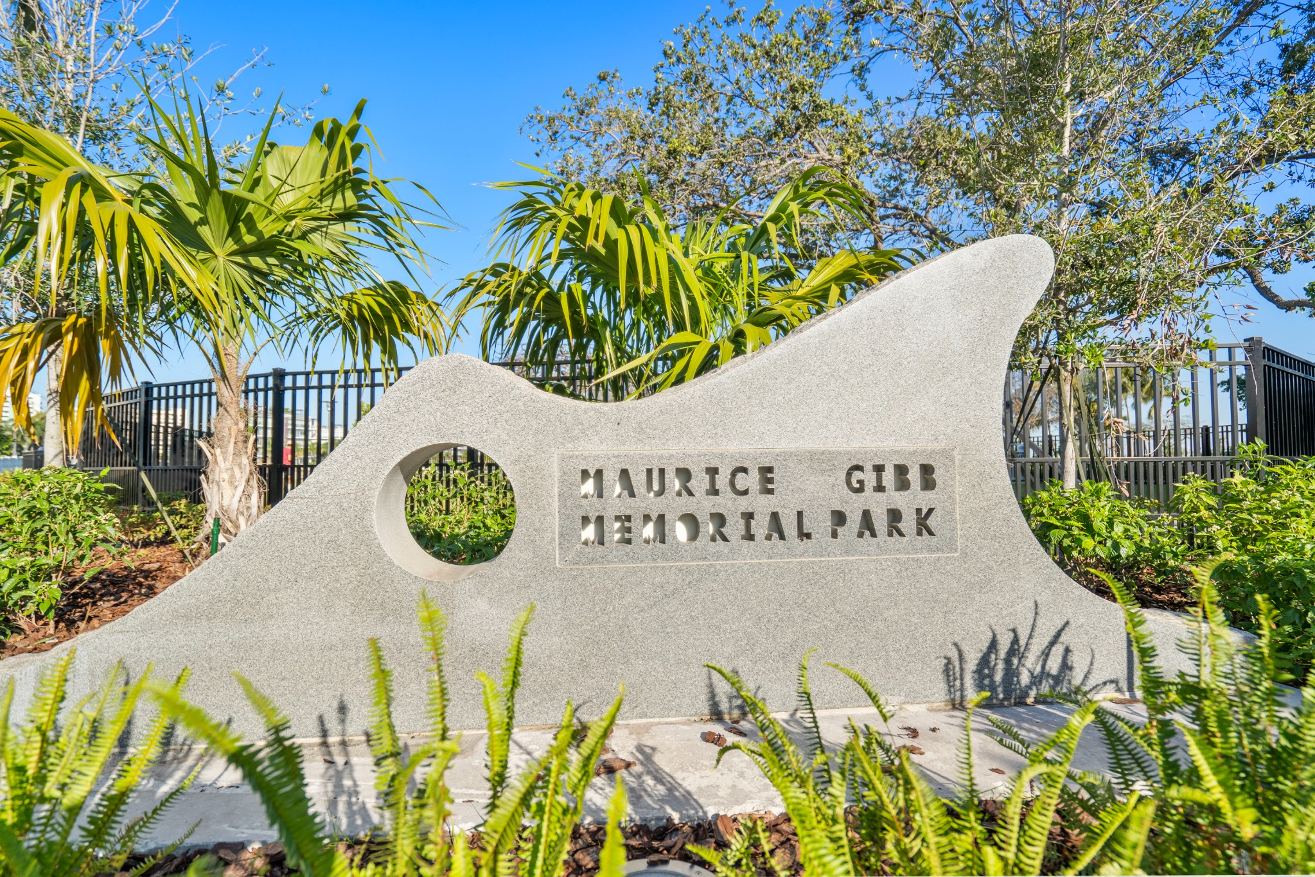

Project Overview
Lunacon Construction Group is proud to have completed the transformative renovation of Maurice Gibb Memorial Park in Miami Beach — a project that reflects the power of community-driven design, environmental stewardship, and resilient infrastructure.
Completed in partnership with the City of Miami Beach and Miami-Dade County, this revitalization effort reimagined one of the city’s beloved waterfront destinations into a safer, more inclusive, and environmentally conscious public space for residents and visitors alike.

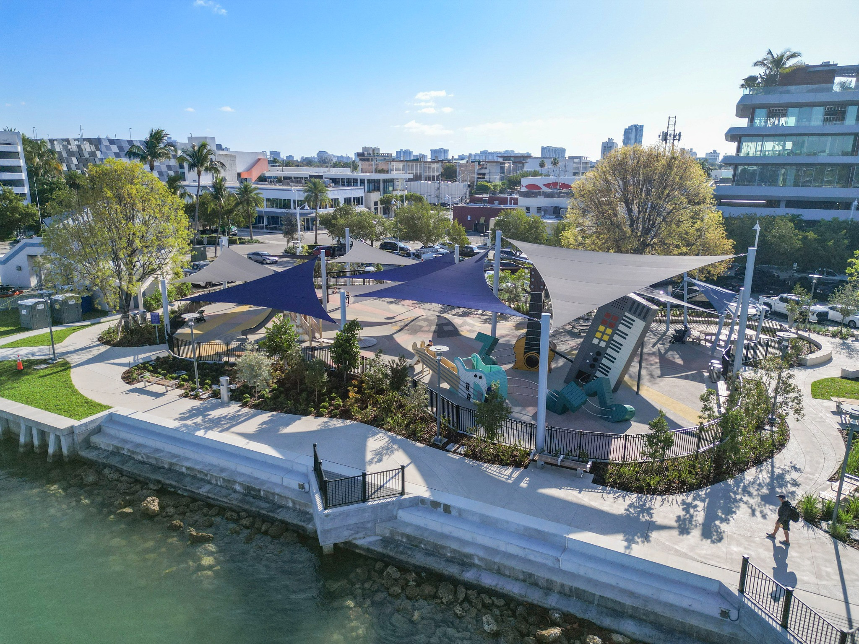

A Project Rooted in Environmental Responsibility
The project began with a significant environmental challenge: the discovery of petroleum contamination on-site. In response, Lunacon led a comprehensive soil and groundwater remediation process in close coordination with the Environmental Consultant and Miami-Dade County’s Division of Environmental Resources Management (DERM).
Our team maintained strict regulatory compliance throughout every phase of the remediation effort, ensuring the site was safely restored while protecting the surrounding ecosystem and community.
This early phase of work set the tone for the entire project — thoughtful, collaborative, and rooted in long-term sustainability.

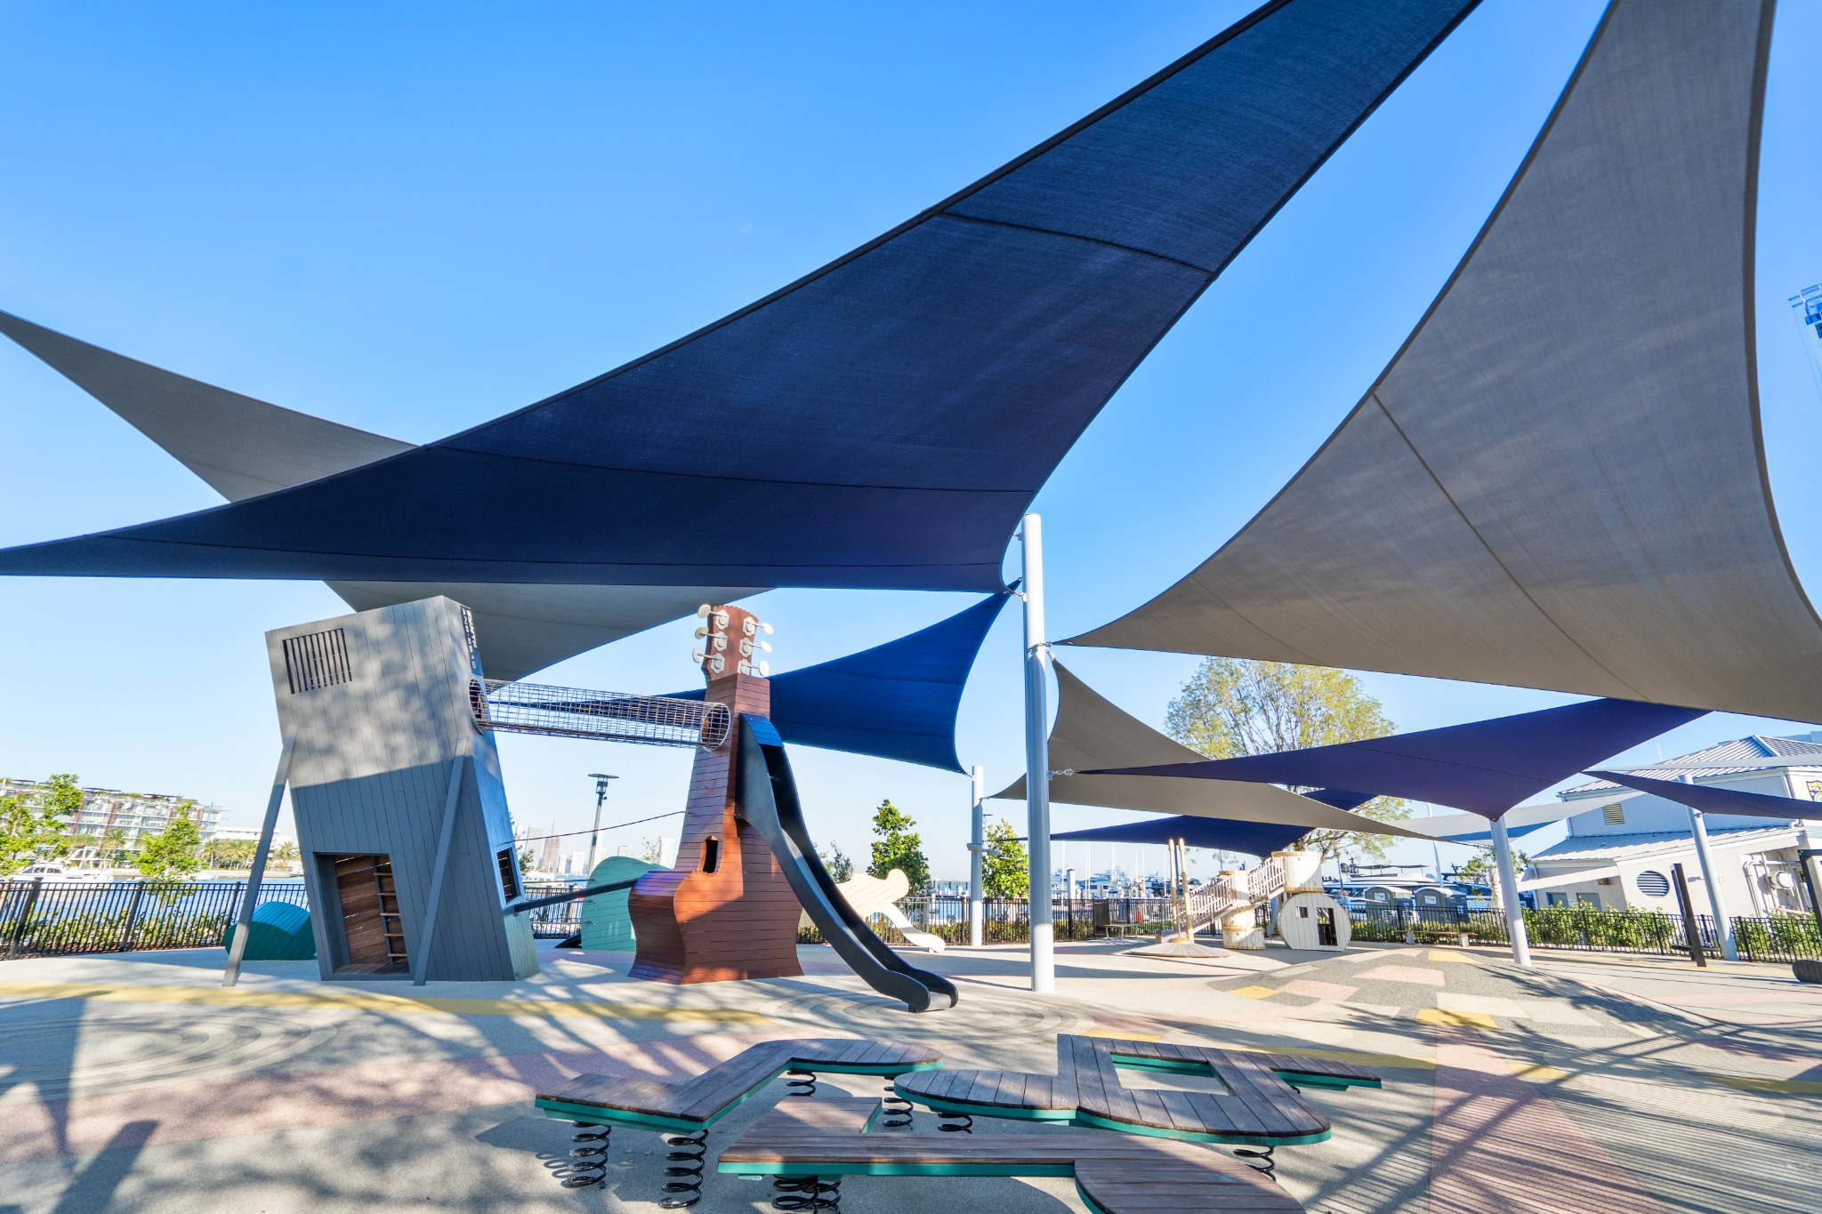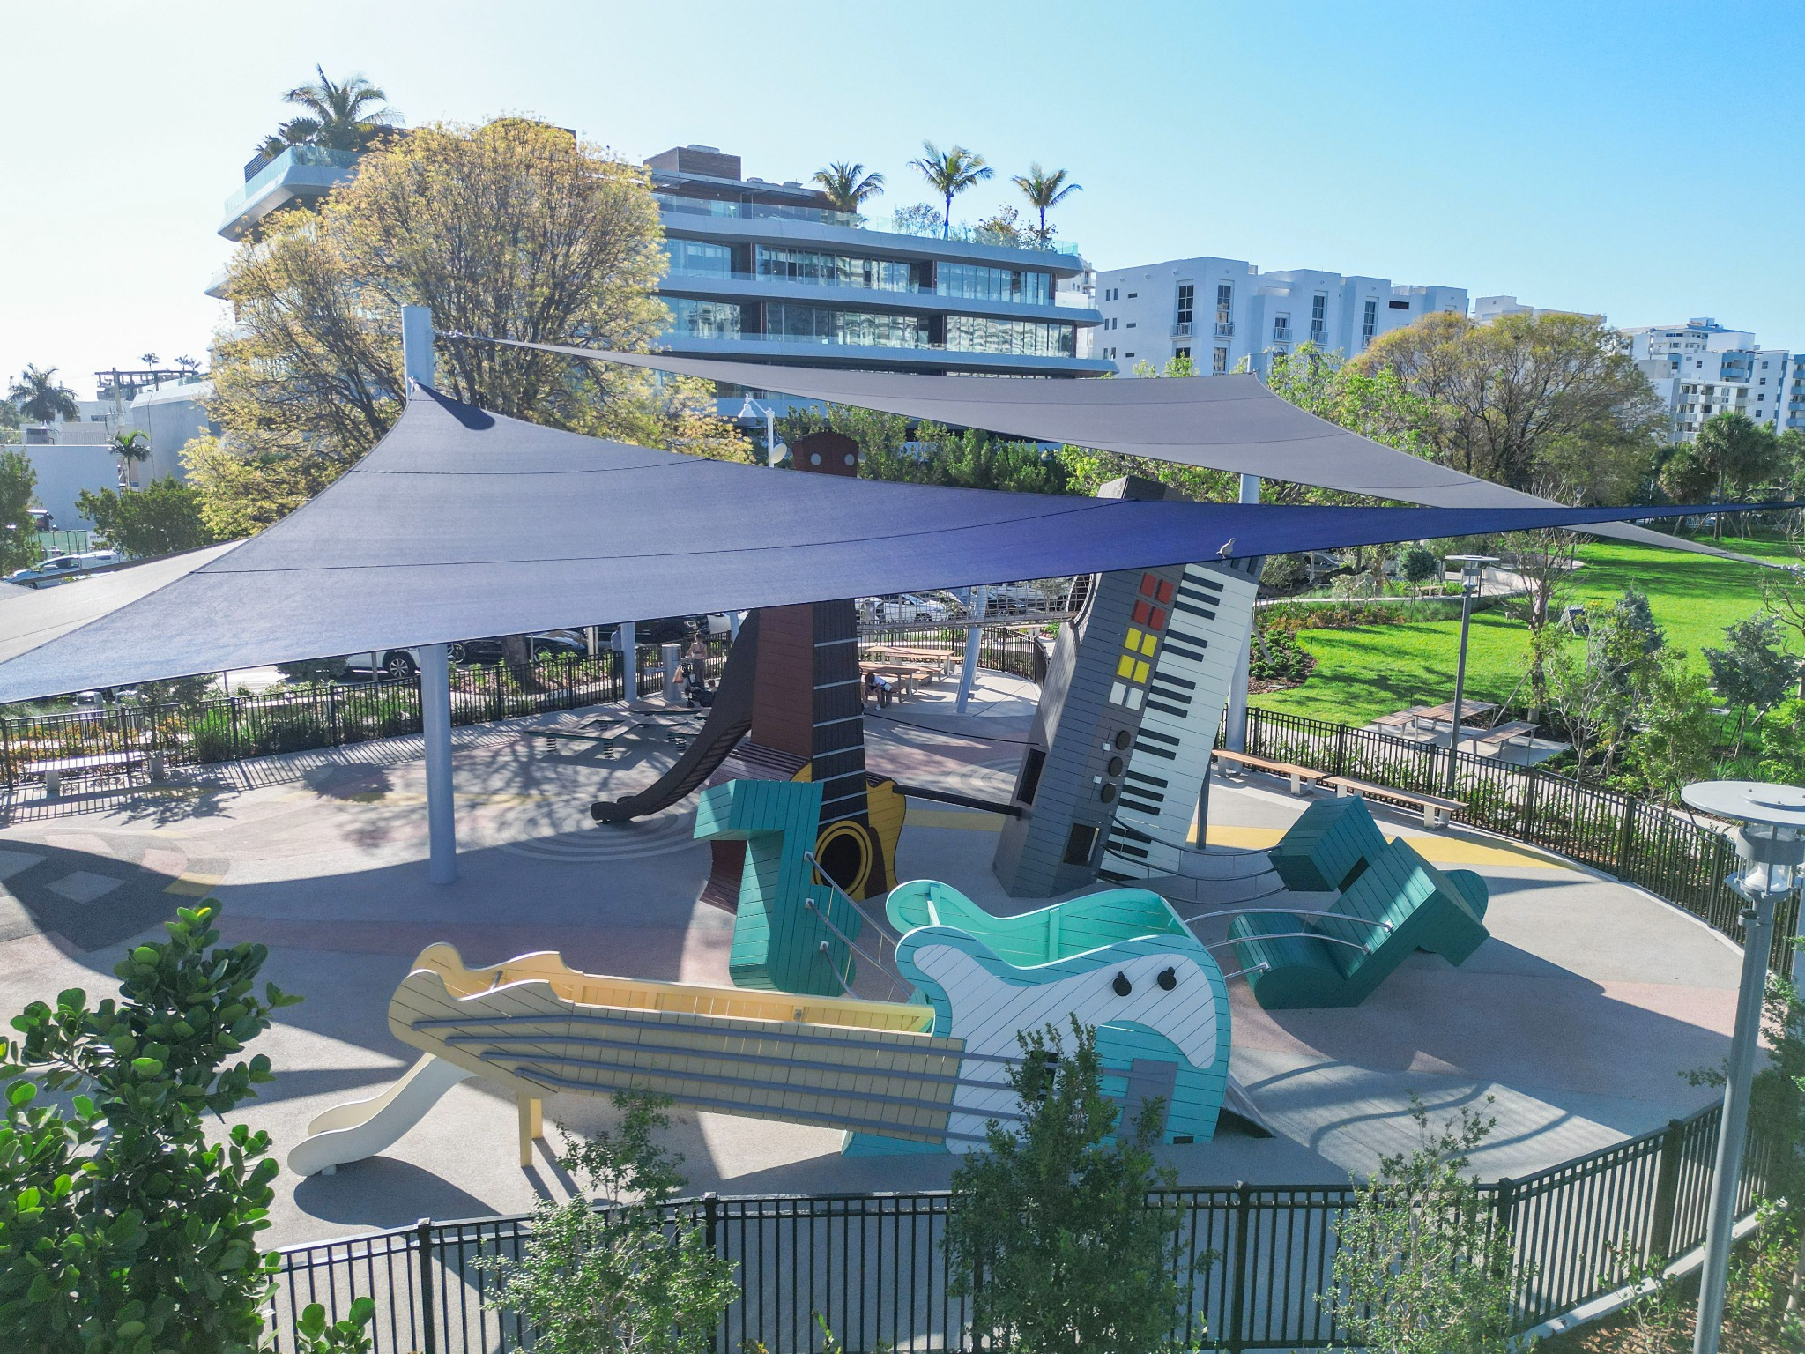
(Pagtabihin mo na lang yung dalawang photo dito Karl, para siya naka collage)

Reimagining a Community Landmark
With valuable input from the surrounding community, the park was redesigned to create a more welcoming and resilient public space while preserving the natural beauty and character of the waterfront.
The revitalized Maurice Gibb Memorial Park now includes:
- Upgraded playground equipment and park furnishings
- Native landscaping and enhanced green spaces
- Improved signage throughout the park
- Scenic overlook areas with views of Biscayne Bay
- A new fishing pier
- Picnic and gathering areas
- A dedicated dog park
- Expanded living shoreline elements
Every enhancement was carefully planned to improve accessibility, recreation, and the overall visitor experience while strengthening the park’s environmental resilience.

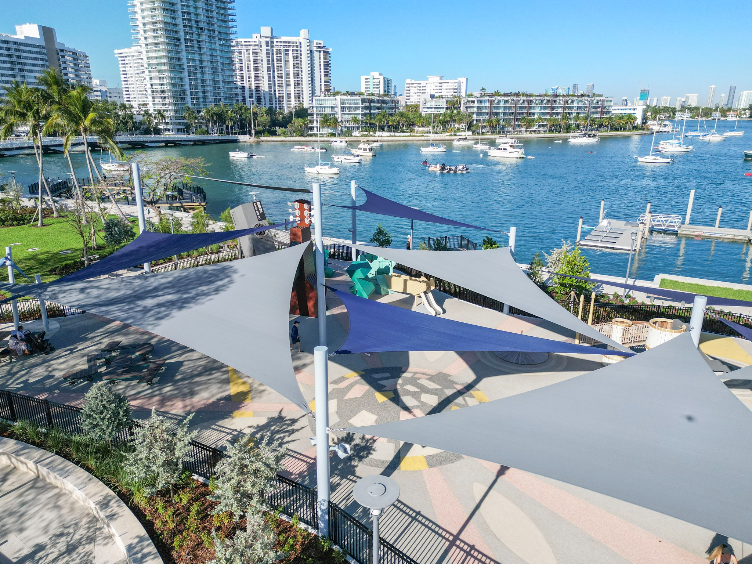

Building for Climate Resilience
As part of Lunacon’s commitment to future-focused infrastructure, the project incorporated several climate adaptation measures to help mitigate the impacts of sea level rise and coastal flooding.
These efforts included:
- Raising the existing seawall
- Extending the living shoreline
- Elevating sections of the park grounds to improve environmental conditions and long-term resilience
These improvements not only protect the park’s infrastructure but also support Miami Beach’s broader sustainability and resiliency goals.

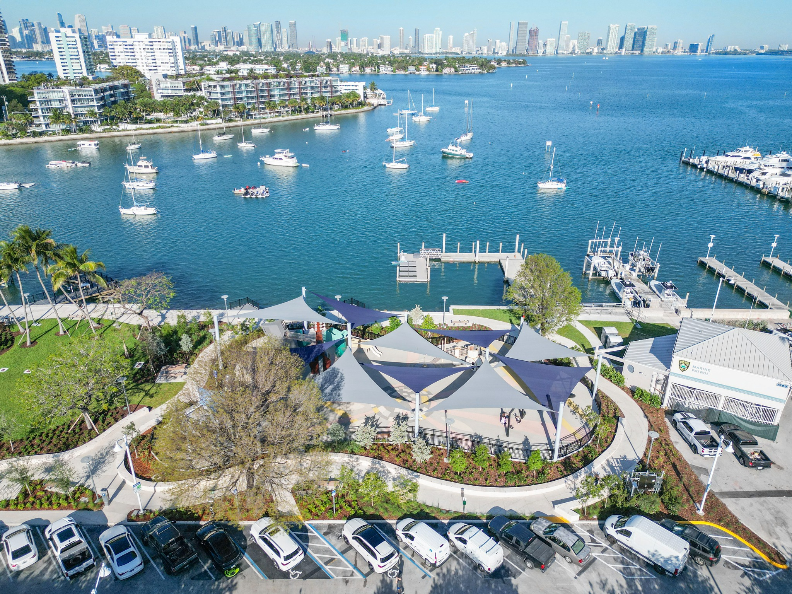

Collaboration Behind the Vision
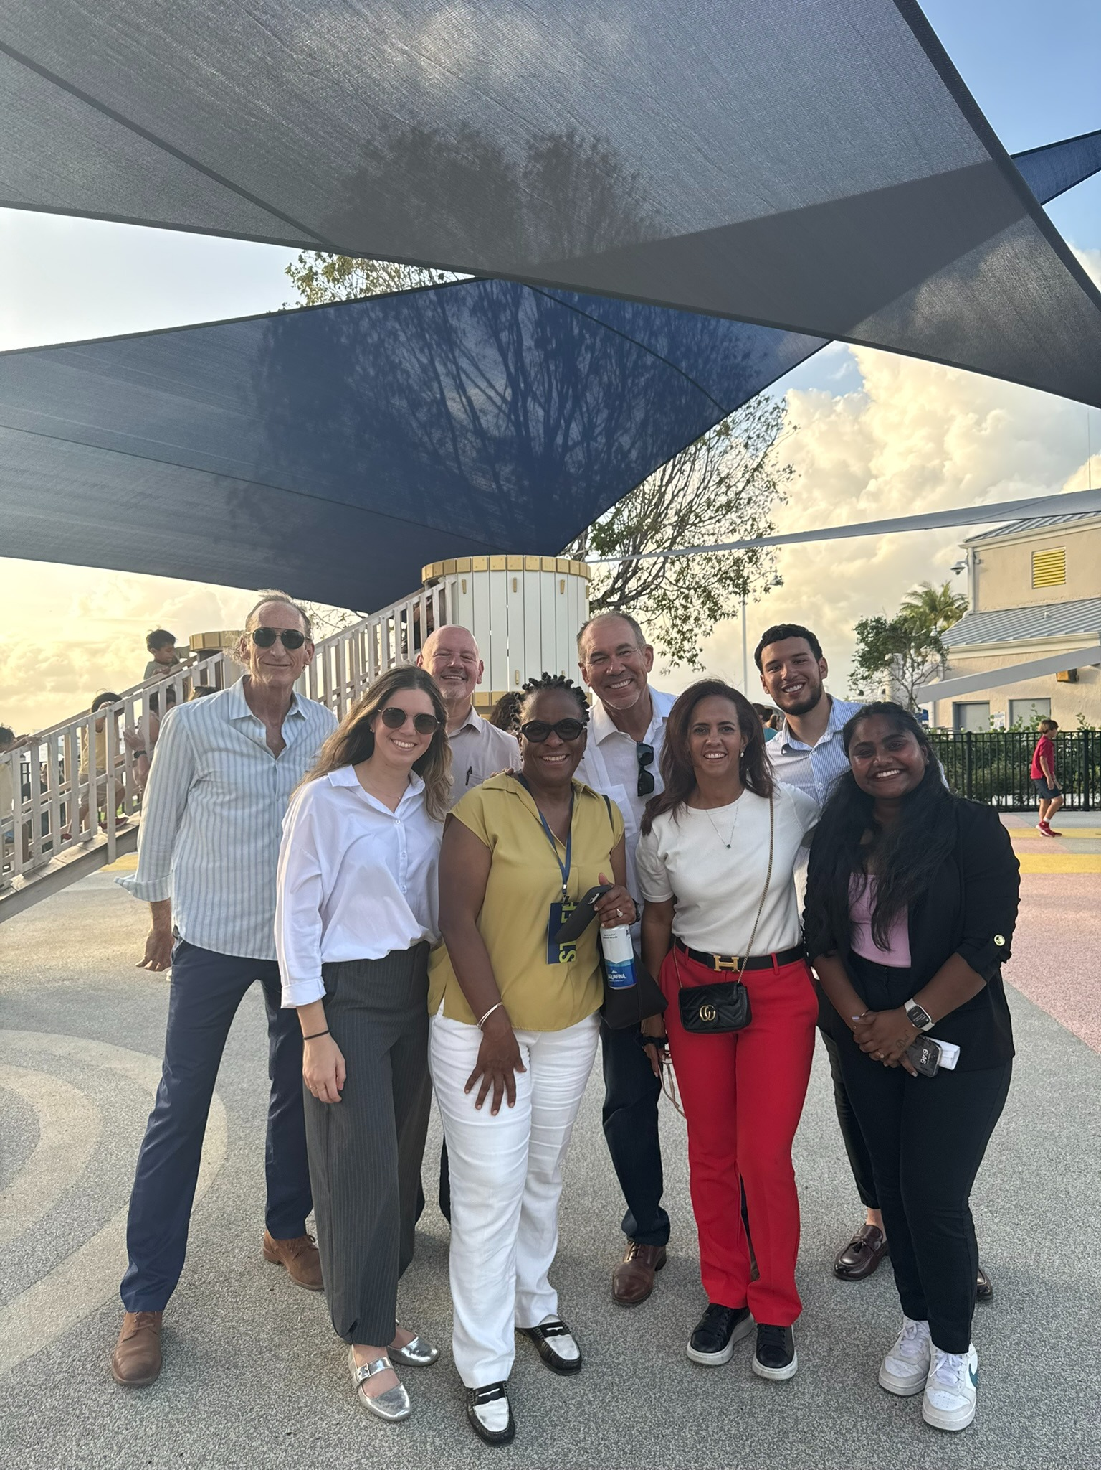
Projects like Maurice Gibb Memorial Park are only possible through collaboration, communication, and a shared commitment to community impact.
Throughout construction, Lunacon carefully coordinated operations to minimize disruption while maintaining uninterrupted access to essential public amenities, including parking areas, docks, pump stations, and the Marine Patrol office.
Safety, environmental stewardship, and community access remained priorities throughout every phase of construction.

A Celebration of Community and Legacy
The newly expanded Maurice Gibb Memorial Park officially celebrated its grand opening on April 3, honoring the legacy of music legend Maurice Gibb while providing a vibrant destination for the Sunset Harbour community.
“Maurice Gibb Memorial Park is a true gem in our Sunset Harbour community — a stunning, family-friendly public space with so many amenities for everyone to enjoy,” said Miami Beach Mayor Steven Meiner.
Funded through the voter-approved 2018 General Obligation Bond, the completed project stands as a testament to what can be accomplished through collaboration, vision, and community-centered leadership.
(Highlights Video)

Building Spaces That Stand the Test of Time
For Lunacon Construction Group, this project represents more than a park renovation.
It reflects our dedication to building infrastructure that serves communities, protects the environment, and creates lasting impact for future generations.
From environmental remediation to resilient waterfront construction, Maurice Gibb Memorial Park demonstrates the importance of thoughtful planning, collaboration, and purpose-driven execution.
We are honored to have played a role in bringing this vision to life for the City of Miami Beach and its residents.

Follow @lunaconcg for more projects focused on resilient construction, community impact, and purpose-driven leadership.

