DAN BUCK
7759 NW 14th Place
Miami, Florida 33147
Direct: 786.560-8561
Email: buckdan@rocketmail.com
Objective
To secure a position within an established company where my skills and experience will be utilized, and opportunity for future advancement as a Construction Manager can be fulfilled.
Qualifications Summary
- Hard-working, conscientious, and intelligent interested in local employment as construction manager.
- Extremely skilled in planning and execution of special projects in time-critical environments.
- Extensive knowledge in directing, coordinating and exercising authority for planning, organization, control and completion of projects.
- Conducted critical inspections on High rise homes and provided reports detailing issues found.
- Very skilled at solving customer relations issues by seeking first to understand and then to be understood.
- Effectively able to communicate with customers, contractors, management and owners.
Education
University of Miami, 06/2007 Bachelor of Business & Construction
- Certificate of Achievement in Building Codes & Inspection (May 2008)
- Concentration in Uniform Building Codes & Inspection, Electrical, Mechanical, Plumbing and Seismic/fire Codes and Inspection.
10-Hour OSHA Safety Card
30-Hour OSHA Safety Card
Proficient in CONUS and OCONUS, MS Word, Excel, Power point and spreadsheets.
Work Experience
Superintendent: Oct. 2010 - Current, GT MC Donald, Plantation, FL
Luxury Condos: Monad Miami Beach, FL.
Luxury Condos: Palau Miami Beach, FL.
Luxury Hotel: The Carlton Miami Beach, FL.
Luxury Hotel: Hyatt Miami Beach, FL.
Ft. Lauderdale Airport Ft. Lauderdale, FL.
- Responsibilities include all operations, procurement, scheduling, quality control, and production/pre-production, reporting status and progress and chairing meetings.
- Extensive knowledge in interacting with architects, owners, building inspectors, utility representatives, and subcontractors.
- Other duties: Examining and inspecting work progress, equipment and construction site to verify safety and ensure that specifications are met, analyzing and planning installation and construction of equipment and structures, conferring with supervisory personnel and subcontractors to discuss such matters as work procedures, complaints, and construction problems, and contracting workers to perform construction work in accordance with specifications.
Construction Superintendent: Nov. 2006 - Aug. 2010, Port of Miami, Miami, FL
- Duties included scheduling, paperwork, and material tracking
- Followed government guidelines while dealing with multi-national clientele, addressing both practical necessities and duties required to sustain a standard of living in a harsh environment under less than ideal conditions, while maintaining a high volume of productivity and a high-quality product.
- Other responsibilities: Verifying materials loaded and unloaded against work order, scheduling times of shipment and mode of transportation, inspecting equipment and verifying conformance to standards, observing work procedures to ensure quality of work and estimating material and worker requirements to complete job.
Carpenter/Supervisor: July 2003 - Oct. 2005, Turner Construction, Miami, FL
- Built and maintained sites for the coal industry
- Supervised and distributed work amongst 50+ employees.
- Other activities: Buildouts, punch-lists, labor distribution, time-sheet tracking, coordinating labor and material deliveries, checking a number of sites and assessing and addressing their needs.
- Completed underground training, July 2001 - Oct. 2002

Areas of expertise include:
• Manage overall project budget and schedule. • Supply ordering/control
• Develop budgets from conceptual designs • Troubleshooting
• Manage design process to meet budget • Site Management
• Complete projects on schedule • Civil Work
• Layout • Masonry Work
• Blueprints/Drawings • Quality Control/Safety

*References available upon request.

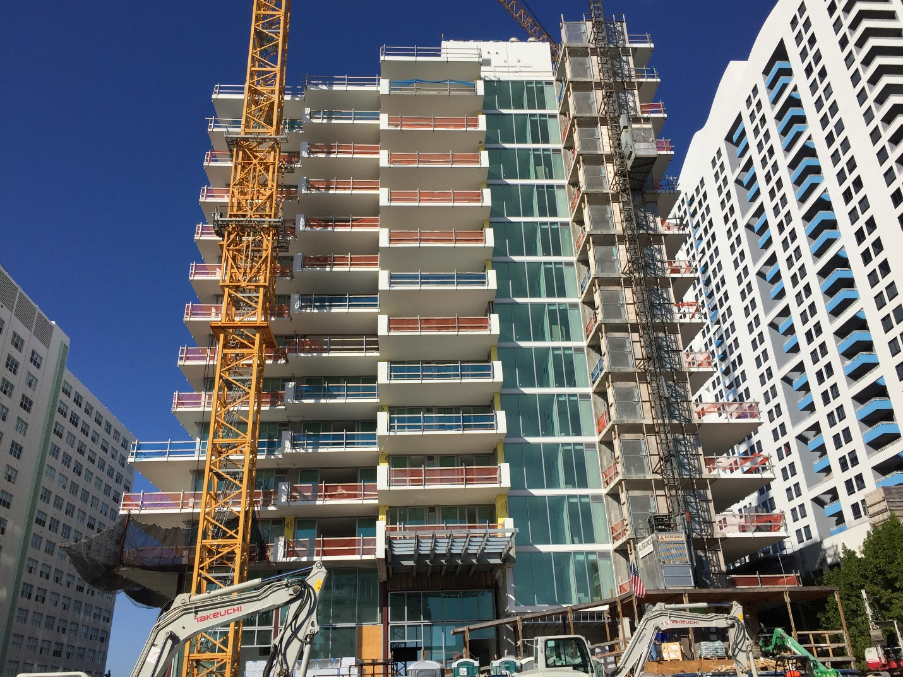
Current Project: Monad Terrace

